Docker Assignment

Sanaullah Shar  
2112235  
  
Backend

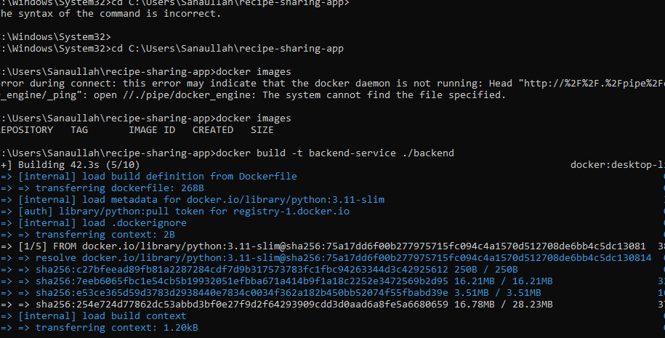  
  
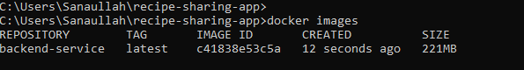

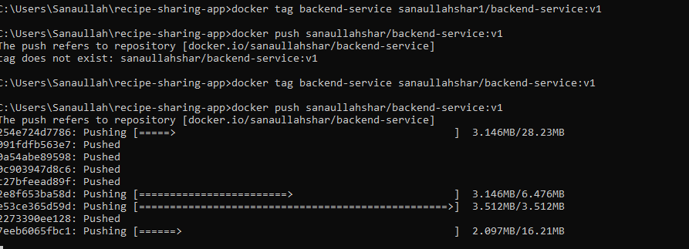

Fronted  
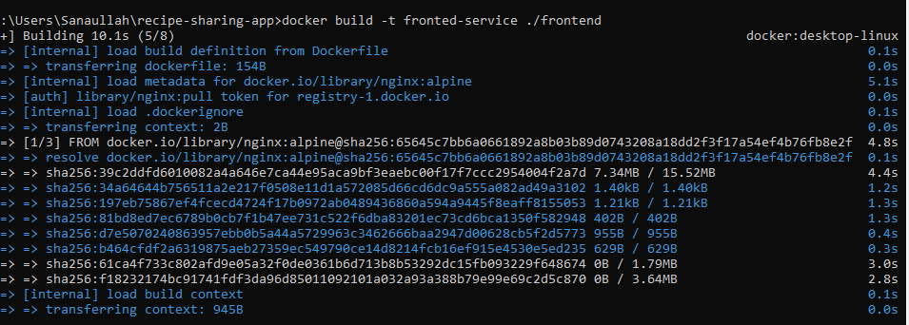  
  
  
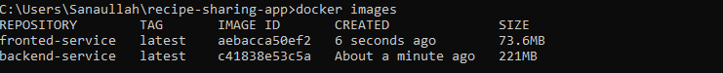  
  
  
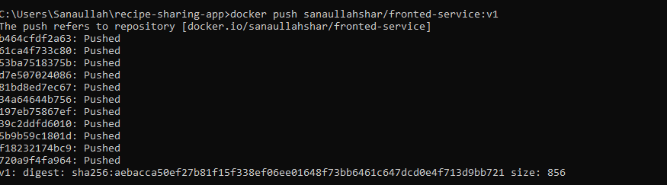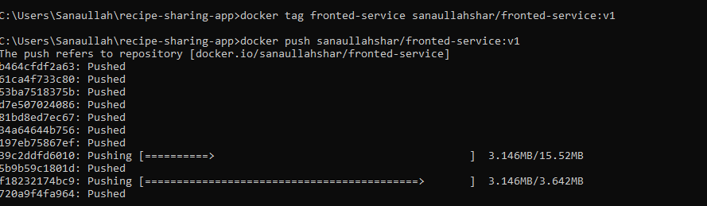

Logger  
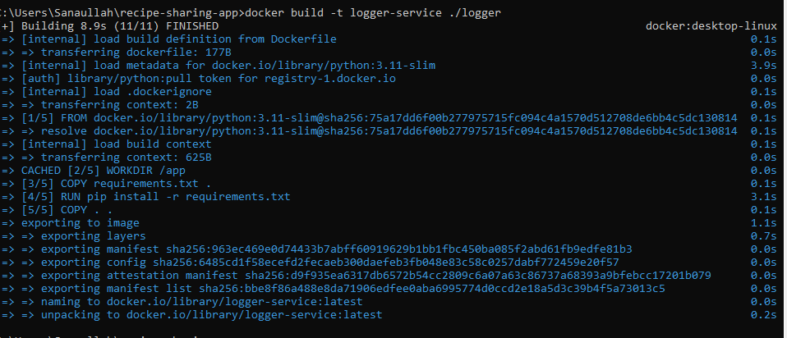  
  
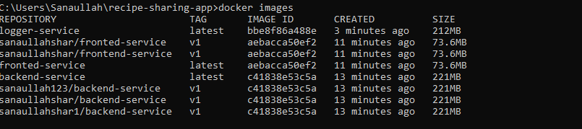  
  
  
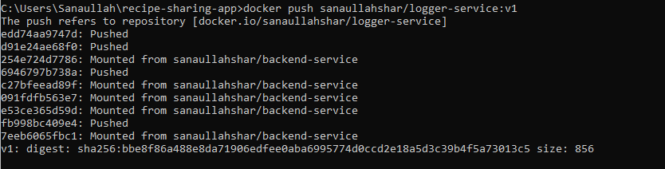  
  
  
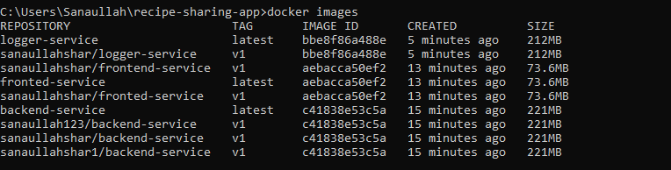

Mongo DB

